

COSHH Policy

1. Policy Statement
At Walk in the Park Nursery, the safety, health, and well-being of children, staff, and visitors are our highest priority. The nursery recognises the importance of controlling exposure to hazardous substances and implements this policy to ensure full compliance with the Control of Substances Hazardous to Health Regulations 2002 (COSHH) and other related health and safety laws.
We aim to prevent or minimise exposure to harmful chemicals, cleaning agents, and other hazardous substances by implementing strict control procedures, clear communication, regular training, and robust risk assessments.

2. Purpose and Scope
This policy outlines how hazardous substances will be identified, assessed, stored, used, and monitored in the nursery setting. It applies to:
- All staff and volunteers
- Any contractors or third-party cleaners
- Any visitors or professionals entering the premises
- All areas where substances are stored or used, including cleaning cupboards, kitchens, bathrooms, and outdoor areas

Key purposes:
- To prevent injury or ill health resulting from hazardous substances.
- To ensure safe handling, storage, and disposal of such substances.
- To protect children, especially those with SEND or medical conditions, from exposure risks.
- To comply with legal obligations under COSHH and EYFS welfare requirements.

3. Responsibilities of Management
Management is responsible for overseeing all health and safety policies, ensuring appropriate training and documentation, and maintaining compliance with statutory guidance.
Management duties include:
- Identifying hazardous substances used on site.
- Completing and reviewing COSHH risk assessments for all substances.
- Ensuring appropriate storage facilities are in place.
- Providing staff training on the safe handling and disposal of hazardous materials.
- Ensuring Material Safety Data Sheets (MSDS) are available for all products.
- Reviewing the COSHH policy annually or after incidents or changes in products.

4. Identifying Hazardous Substances
Hazardous substances in early years settings may include cleaning products, disinfectants, paints, glues, and personal care products.
Procedures:
- Maintain a COSHH inventory of all hazardous substances used or stored on site.
- Ensure all products are correctly labelled, and safety data sheets are filed and accessible.
- Avoid using products that are unnecessary or pose significant risk, especially near children.
- Choose child-safe, non-toxic, or eco-friendly alternatives whenever possible.

5. Risk Assessment Process
COSHH requires employers to assess the risks to health posed by hazardous substances and decide on control measures.
Steps taken:
- Identify hazardous substances and how they are used.
- Determine who might be harmed (children, staff, cleaning contractors).
- Assess the level of risk and decide on control measures.
- Record findings on a COSHH Risk Assessment Form.
- Review assessments annually or after an incident or product change.

6. Safe Storage and Handling Procedures
Improper storage of hazardous substances can result in accidents, exposure, or misuse.
Procedures:
- All hazardous products must be kept in a locked cupboard, out of reach of children.
- Products must never be decanted into unlabelled or inappropriate containers.
- Personal Protective Equipment (PPE) such as gloves or aprons must be worn where necessary.
- Ensure only trained staff handle hazardous substances.
- Clear signage must be in place to indicate storage of harmful substances.

7. Use of Hazardous Substances
Children must never come into contact with cleaning chemicals or other hazardous products during the nursery day.
Procedures:
- Cleaning must take place before children arrive, during quiet times, or after hours.
- No cleaning or spraying of chemicals when children are eating or present.
- Windows should be opened for ventilation during and after cleaning.
- Staff must never leave cleaning buckets, sprays, or detergents unattended.

8. Disposal of Hazardous Substances
Hazardous waste must be disposed of safely and in line with environmental and health regulations.
Procedures:
- Follow manufacturer instructions for disposal of each product.
- Never pour hazardous substances down toilets or outside drains unless stated.
- Dispose of expired or unused products via appropriate waste channels.
- Maintain a record of hazardous waste disposal if required.

9. Emergency Procedures
Quick and effective responses to accidental exposure or spillage are critical.
Procedures:
- First aid kits and PPE must be available at cleaning stations.
- In the event of contact with skin, eyes, or ingestion, follow product safety instructions and contact emergency services if necessary.
- Spill kits should be available and used according to procedure.
- All incidents must be recorded in the Accident and Incident Log and reported to management.

10. Children with SEND and Medical Needs
Children with respiratory conditions, allergies, or SEND may be more vulnerable to chemical exposure. The environment must be adapted to their needs.
Management must ensure:
- Risk assessments are adapted for children with medical vulnerabilities.
- No cleaning products with strong scents, ammonia, or known allergens are used near sensitive children.
- Individual Health Care Plans (IHCPs) reflect additional precautions where applicable.
- All staff are informed of individual children’s health or behavioural responses to chemical exposure.

11. Inclusion and Anti-Discrimination
All children and staff have the right to a safe environment, regardless of disability, gender, race, religion, or background. COSHH procedures must not create barriers to access or disadvantage.
Management responsibilities:
- Ensure that cleaning routines and materials do not disproportionately affect children with sensory sensitivities or cultural needs (e.g. avoiding alcohol-based cleaners during specific religious observances).
- Provide alternative safe spaces for children who may be affected during cleaning or maintenance.
- Ensure visual aids and simplified communication is used to explain hazards to children with SEND or EAL.

12. Training and Communication
All staff must be trained to understand and apply COSHH procedures confidently.
Management responsibilities:
- Provide induction and annual refresher training on COSHH procedures.
- Ensure all staff can locate and understand risk assessments and safety data sheets.
- Use visual COSHH signs to alert staff to hazardous materials and storage areas.
- Include COSHH responsibilities in staff handbooks and supervision discussions.

13. Review and Monitoring
The COSHH policy and associated risk assessments must be regularly reviewed to reflect current practice and guidance.
Management responsibilities:
- Review the COSHH Policy annually or following any incident or change in legislation.
- Audit hazardous substance logs and risk assessments termly.
- Conduct random spot checks on storage and usage compliance.
- Include COSHH compliance in health and safety checklists and Ofsted readiness reviews.

14. Legal and Statutory Frameworks
This policy is based on the following statutory guidance and legal frameworks:
- Control of Substances Hazardous to Health Regulations (COSHH) 2002
- Health and Safety at Work Act 1974
- Statutory Framework for the Early Years Foundation Stage (EYFS) 2024
- Management of Health and Safety at Work Regulations 1999
- Children Act 1989 and 2004
- Equality Act 2010
- SEND Code of Practice (2015)
- Working Together to Safeguard Children (2018, updated 2023)
- DDSCP – Derby and Derbyshire Safeguarding Children Partnership Procedures
- REACH Regulation (EC) No 1907/2006 on chemical safety

1. COSHH Risk Assessment Template
A clean, easy-to-use form for assessing each hazardous substance, including:
- Substance name & purpose
- Manufacturer/supplier info
- Hazard symbols
- Potential risks
- Who might be affected
- Control measures
- PPE required
- First aid guidance
- Disposal method
- Date of review & initials

2. Staff COSHH Induction Checklist
A staff-facing document covering:
- Key responsibilities under COSHH
- How to read hazard labels
- Where to find risk assessments & MSDS
- Safe storage and usage rules
- Emergency procedures
- SEND and inclusive practice considerations

3. Visual COSHH Cupboard Poster
A bold, laminated-style sign you can place inside COSHH cupboards, showing:
- “Hazardous Substances Stored Here”
- PPE symbols
- Simple icons for “Keep Locked,” “No Children,” and “Wash Hands”
- QR or location reference for MSDS folder
- Emergency contact/first aider listed

Appendix 1 – COSHH Process Flow Chart
IDENTIFY ALL HAZARDOUS SUBSTANCES USED OR PRODUCED FROM PROCESSES AND LISTS THEM ON FORM
YES
NO
NO

Or
YES

Appendix 2 – Classification, Labelling and Packaging of Substances and Mixtures (CLP) Pictograms
REVIEW AT REGUALR INTERVALS OR WHEN A PROCESS, EQUIPMENT OR PERSON ALTERS
ESTABLISH A SAFER ALTERNATIVE SUBSTANCE TO USE AND/OR AN ALETERNATIVE MEANS OF CARRYING OUT THE TASK
YES
YES
NO
NO
CONCERNS OR PROBLEMS IDENTIFIED?
MONITOR:
SUPERVISION, INSPECTIONS, HEALTH SURVEILLANCE, AIR MONITORING, MAINTENANCE OF EQUIPMENT, PPE INSPECTIONS, REFRESHER TRAINING
IS THE LEVEL OF RISK ACCEPTABLE?
IMPLEMENT CONTROLS TO REDUCE THE HAZARDS/RISKS OF HAZARDOUS SUBSTANCES
CAN SUBSTANCE BE SUBSTITUTED FOR A SAFER ALTERNATIVE?
SEND COMPLETED HSFORM1007 AND ELECTRONIC COPIES OF SAFETY DATA SHEETS TO HEALTH AND SAFETY TEAM
USE COSHH GUIDANCE HSGUI007 TO PRODUCE OWN COSHH RISK ASSESSMENTS ON HSFORM2007
DISPOSE OF SUBSTANCE AND REMOVE FROM COSHH INVENTORY. REVIEW AT REGUALR INTERVALS OR WHEN A PROCESS, EQUIPMENT OR PERSON ALTERS
YES
CAN THE USE OF A HAZARDOUS SUBSTANCE BE ELIMINATED?

Label | What Does It Mean? | Examples
 | Contains Gas Under Pressure  - May explode if heated,  - May cause cryogenic burns or injury. | - Gas Containers
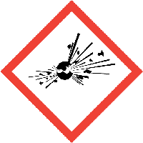 | Explosive  - Unstable or Mass explosion hazard  - Fire, blast or projection hazard | - Fireworks  - Ammunition
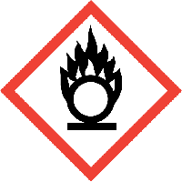 | Oxidising  - May cause or intensify fire  - May explode in fire | - Bleach  - Oxygen for medical purposes
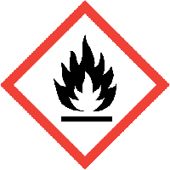 | Flammable  - Flammable gas, aerosol, liquid, vapour or solid | - Petrol  - Nail polish remover
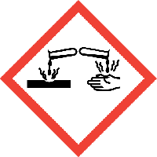 | Corrosive  - May be corrosive to metals  - Causes severe skin burns and eye damage | - Drain cleaners  - Hydrochloric acid  - Ammonia
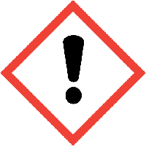 | Irritant/Harmful  - Can cause allergic reaction or serious eye or skin irritation  - Harmful if swallowed, in contact with skin or inhaled | - Detergents  - Toilet cleaner  - Coolant fluid
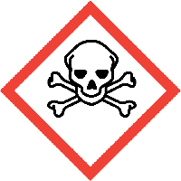 | Acute Toxicity  - Fatal or toxic following contact with skin, swallowed or inhaled | - Pesticide  - Biocide  - Methanol
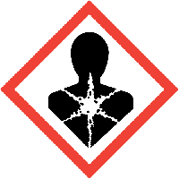 | Health Hazard  - May be fatal if swallowed  - May cause genetic defects, allergy or asthma symptoms or breathing difficulties if inhaled | - Turpentine  - Petrol  - Lamp oil
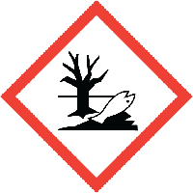 | Hazardous to the Environment  - Toxic to aquatic life with long lasting effects | - Pesticides  - Petrol  - Turpentine

 | COSHH Risk Assessment No:
School: |  |  |  |  |  |  |  | Student name:
Describe the activity or work process.
(Include how long and how often this is carried out and the quantity of substance used)
Location of process being carried out?
Identify the persons at risk: |  |  |  | Goldsmiths Employees  (including trainees) |  |  |  |  | Contractors |  |  | Public  (including students)
Name the substance involved in the process and its manufacturer.
(A copy of a current safety data sheet for this substance should be attached to this assessment)
Classification of Hazard
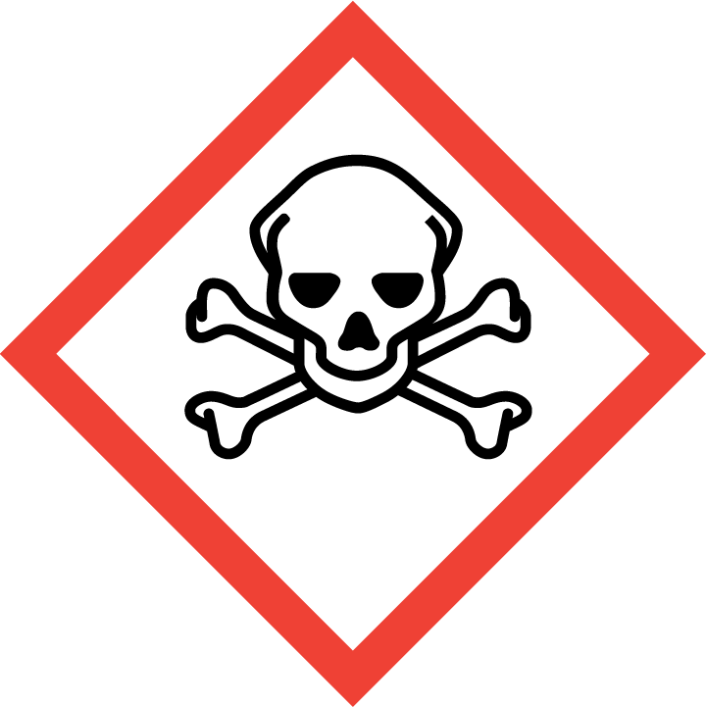 |  | Can harm or kill if swallowed, inhaled or in contact with skin. | 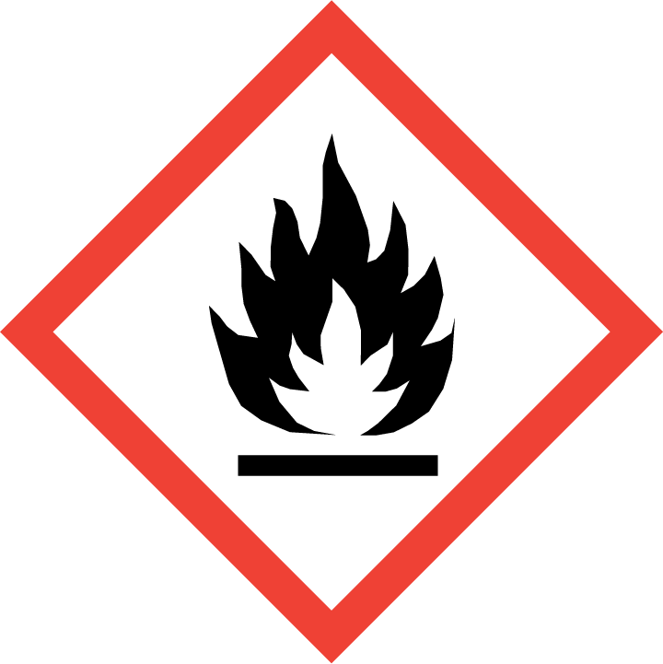 |  | Highly or extremely flammable gas, aerosol, liquid and vapour.
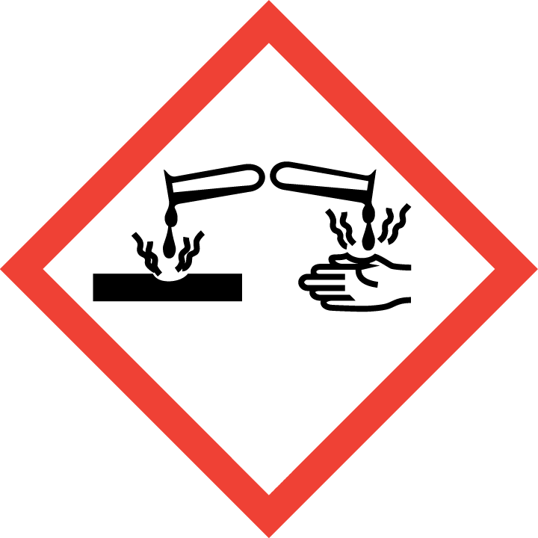 |  | May corrode metals, cause severe skin burns and eye damage. | 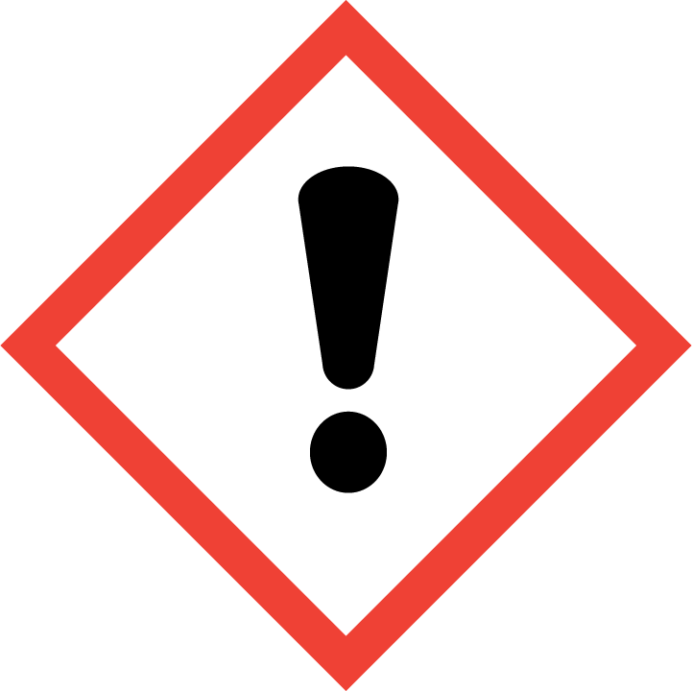 |  | May cause allergic skin reaction or serious eye irritation; harm if swallowed or inhaled; harm to the environment.
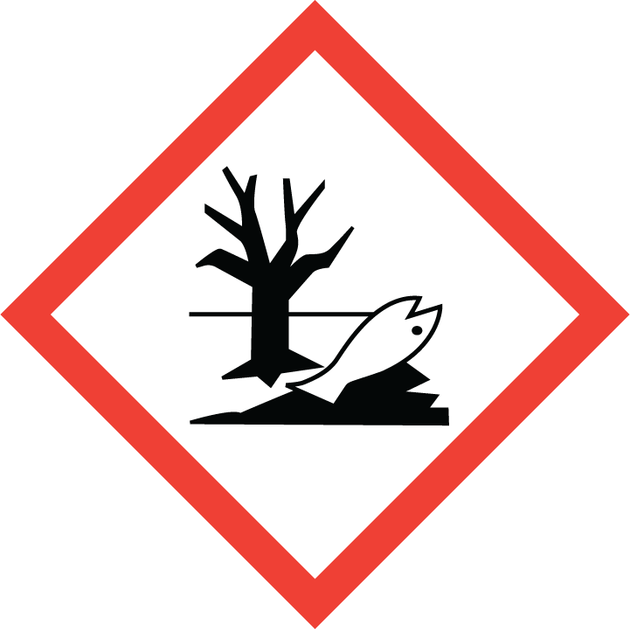 |  | Toxic to the aquatic life. | 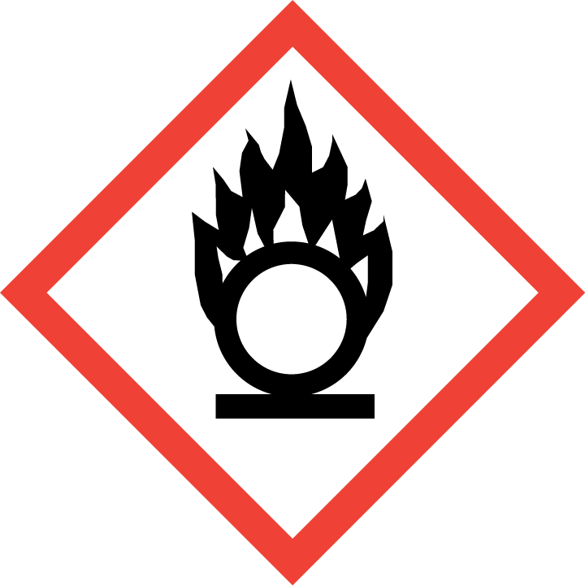 |  | May cause fire (or intensify it) or explosion.
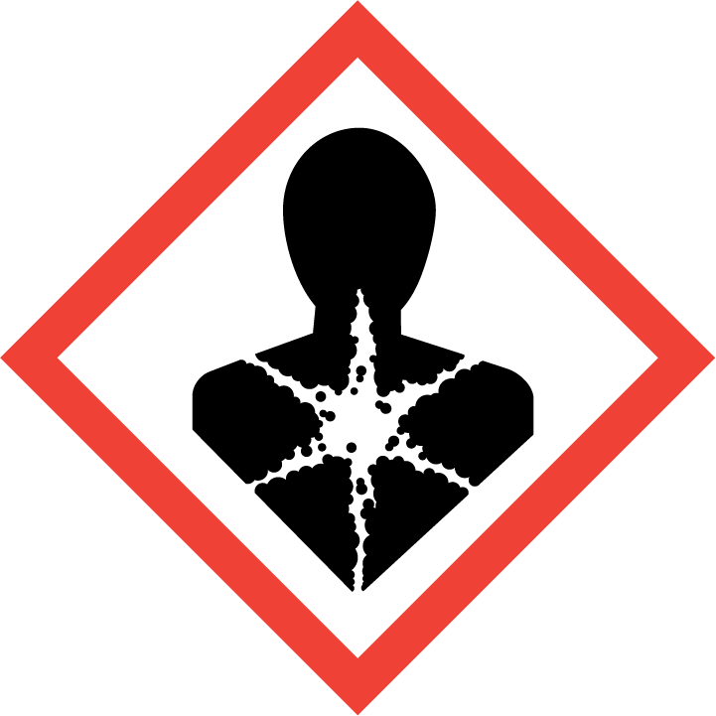 |  | May damage fertility or the unborn child, cause cancer, allergies or asthma symptoms, damage organs. | 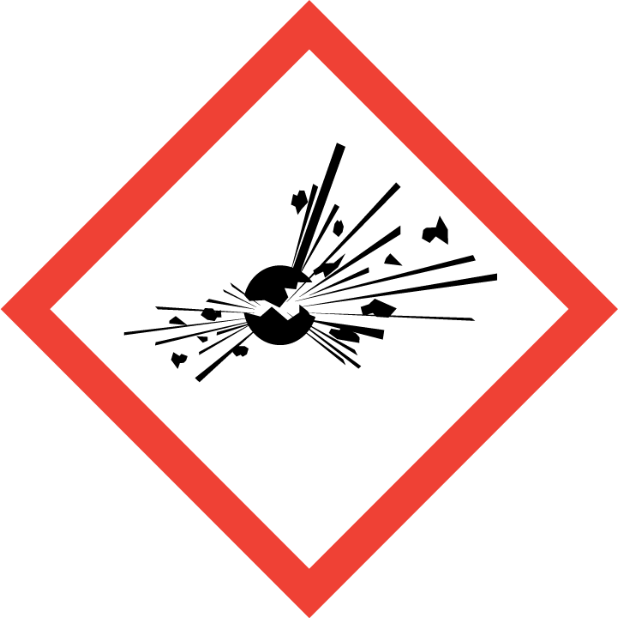 |  | Unstable explosive. Mass explosion hazard.
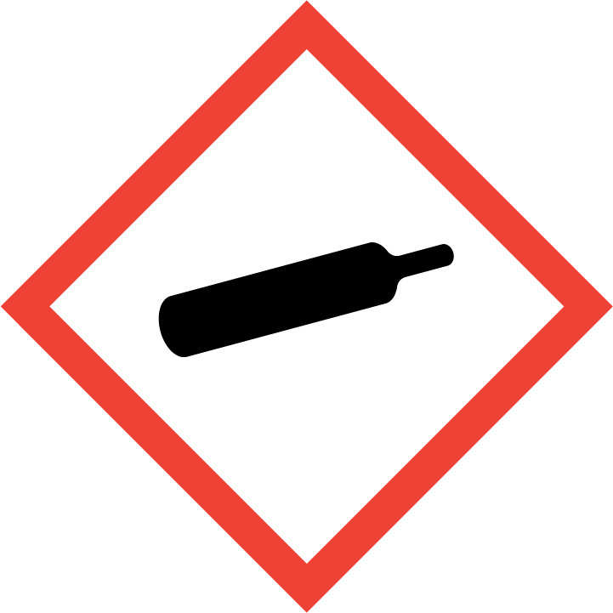 |  | May explode if heated, cause burns or injury.

Hazard Type
Gas Vapour Mist Fume Dust Liquid Solid Other (State)
Route of Exposure

Inhalation Skin Eyes Ingestion Other (State)
Workplace Exposure Limits (WELs) please indicate n/a where not applicable
Long-term exposure level (8hrTWA): |  |  |  |  |  |  | Short-term exposure level (15 mins):
State the Risks to Health from Identified Hazards
Control Measures: (for example extraction, ventilation, training, supervision). Include special measures for vulnerable groups, such as disabled people and pregnant workers. Take account of those substances that are produced from activities undertaken by another employer’s employees.
Is health surveillance or monitoring required?

Yes No
Personal Protective Equipment (state type and standard)
  Dust mask |  |  |  |  |  |   Visor
  Respirator |  |  |  |  |  |   Goggles
  Gloves |  |  |  |  |  |   Overalls
  Footwear |  |  |  |  |  |   Other
First Aid Measures
Storage
Disposal of Substances & Contaminated Containers
Hazardous Waste Skip Return to Depot Return to Supplier Other

(If Other Please State):
Is exposure adequately controlled? |  |  |  |  | Yes No
Risk Rating Following Control Measures
High Medium Low

Assessed by: Date: Review Date:

